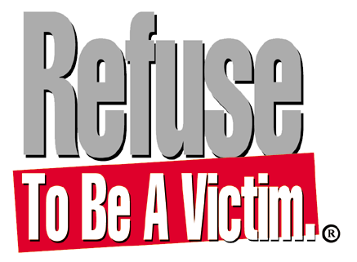

Come attend the Refuse To Be A Victim® crime prevention and personal safety seminar, where you will learn how to create layers of safety in your life to protect yourself and your family from criminal confrontations. You will learn the tools you need to develop your own personal safety strategies, including information on:

The Psychology of Criminal Predators
Mental Preparedness
Home & Cyber Security
Automobile & Travel Security
Personal Protection Options
And more!

Date: (Insert date)
Time: (Insert time)
Location: (Insert address and short directions of necessary)
Cost: (Insert cost and whether it is co-ed or women-only)

Contact (Insert name and appropriate phone number and email) now to register or for more information!

