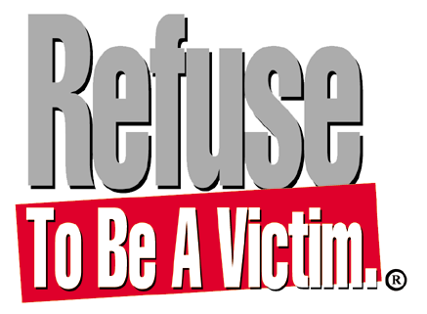

Millions Of People Are Victims of Crime Annually- Don’t Be One Of Them!

Safety experts agree that the single most important step toward ensuring your personal
safety is making the conscious decision to Refuse To Be A Victim®. You stand a much
better chance of preventing criminal confrontations if you develop a safety plan before you
need it. That is why the Refuse To Be A Victim®, a crime prevention seminar, was developed by the National Rifle Association.

The seminar teaches easy-to-understand methods you can use to increase awareness and
prevent criminal confrontation. In just (Insert Time), you will learn the tools you need to
develop your own personal safety strategies, including information about:

The Psychology of Criminal Predators
Home & Cyber Security
Automobile & Travel Security
Personal & Technological Security
Self-Defense Devices and Training Options
And more!

Date: (Insert date)
Time: (Insert time)
Location: (Insert address and brief directions if necessary)
Cost: (Insert cost and whether it is co-ed or women only)

To register or for more information, contact (Insert name and appropriate phone number and email).

