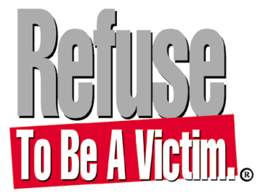

FOR IMMEDIATE RELEASE FOR MORE INFORMATION CONTACT
(Insert date) (Insert your name)
(Inset your telephone number)
(Insert your email)

"REFUSE TO BE A VICTIM® SEMINAR”: 30 SEC. LIVE RADIO SPOT

Safety experts agree that the single most important step toward ensuring your personal
safety is making the conscious decision to Refuse To Be A Victim®. You stand a much
better chance of preventing criminal confrontations if you develop a safety plan before you
need it.

The seminar teaches easy-to-understand methods you can use to increase awareness and
prevent criminal confrontation. You’ll learn the tools you need to
develop your own personal safety strategies, including information about home, phone, automobile, travel, technological, and personal safety- plus much more!

LEARN MORE PERSONAL SAFETY AND CRIME PREVENTION TIPS FROM REFUSE TO BE A VICTIM®. CONTACT CERTIFIED INSTRUCTOR, (Insert your name) AT (Insert your telephone number and email) FOR MORE INFORMATION.

