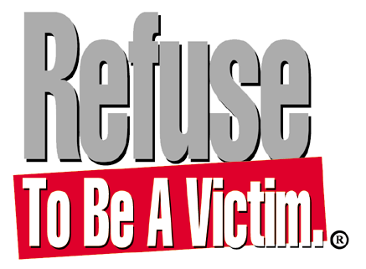

Refuse To Be A Victim® is a nationally recognized crime prevention seminar, a program of the
National Rifle Association, that promotes awareness and prevention of criminal confrontations. Topics covered include: mental preparedness, physical security, home security, travel safety, technological security, and much more!

Seminars are available in (Insert town). For more information or a free brochure, contact certified instructor, (Insert name) at (Insert appropriate phone number and email).

