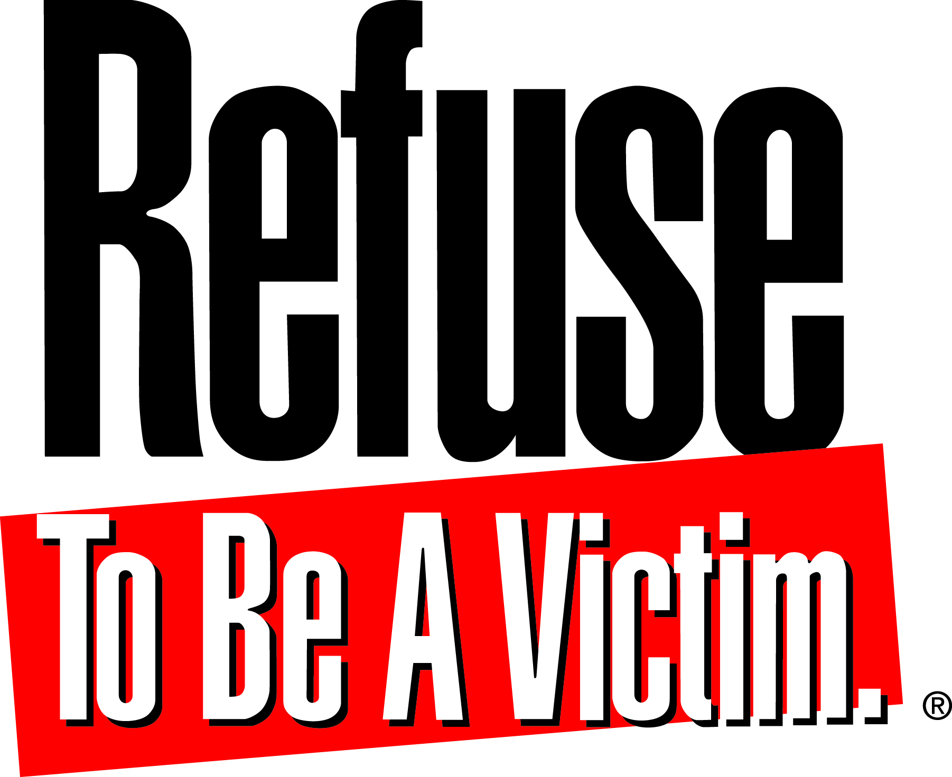

National Rifle Association of America
11250 Waples Mill Road, Fairfax, VA 22030

For Immediate Release
September 19, 2013

Media Contact:
Kyle Jillson (703) 267-1595

Refuse To Be A Victim Crime Prevention Seminar to be Held in Albuquerque, New Mexico

FAIRFAX, Va. – The National Rifle Association’s award-winning crime prevention and personal safety seminar, Refuse To Be A Victim®, will be held June 12, 2013 at Central New Mexico Community College. The program will run from 8:00 a.m. to 12:00 p.m. in the Lecture Hall of the College’s Montoya campus and is open to teenagers and up. Registration is $5.

Developed in response to nationwide requests for crime prevention seminars, Refuse To Be A Victim teaches methods to avoid dangerous situations and prevent criminal confrontations. Seminar participants will be presented with a variety of common-sense crime prevention and personal safety strategies and devices that may be integrated into their personal, home, automobile, telephone, technological, and travel security.

Since 1993, Refuse To Be A Victim has been endorsed by law enforcement members throughout the United States for its positive impact. With more than 7,000 instructors, seminars have been held in all 50 states, the District of Columbia, Puerto Rico, and Trinidad and Tobago.

Those interested in instructing their own Refuse To Be A Victim classes may become certified through attending an Instructor Development Workshop immediately following the seminar. Attendees will learn speaking techniques, presentation skills, instructor responsibilities, and seminar marketing strategies. The workshop is open to the public and a pre-registration fee of $140 is required.

To register, contact NRA Refuse To Be A Victim Executive Counselor Edward O’Carroll at 703-475-4598 or rtbav911@yahoo.com. Visit http://refuse.nra.org/find-a-seminar.aspx for more information.

~ 30 ~

