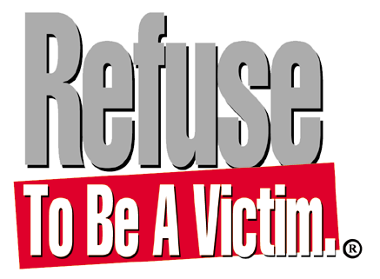

Millions Of People Are Victims of Crime Annually- Don’t Be One Of Them!

Safety experts agree that the single most important factor in surviving a criminal confrontation is
to have a personal safety strategy in place before it is needed. The Refuse To Be A Victim® crime prevention seminar, a program of the National Rifle Association, is pleased to offer this easy-to-understand personal safety information to the (Insert town here) community.

What? Refuse To Be A Victim® is a seminar full of crime prevention and personal safety
strategies you can use to develop your own safety plan. In just (Insert time), you will learn about home, automobile, phone, technology, and personal safety—plus much more!

When? (Insert date and time)

Where? (Insert address and short directions if necessary)

Cost? (Insert cost and whether it is co-ed or women only)

Space is limited. Please contact (Insert name and appropriate phone number and email) to register today!

