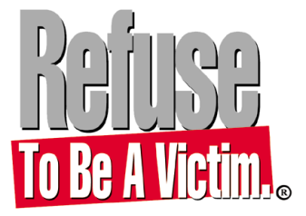
(Insert date)

Dear (Insert name):

I am delighted to introduce you to the Refuse To Be A Victim® crime prevention program.
Enclosed you will find a copy of the program's brochure.

Refuse To Be A Victim® is a two to four hour crime prevention seminar, which provides practical information geared toward awareness and avoidance of criminal confrontation. Certified instructors help seminar participants better understand criminal thinking and provide tips on maximizing home, automobile, telephone, technological, and personal security. Participants will also learn information about how to easily and inexpensively create layers of safety in their everyday lives.

The Refuse To Be A Victim® program so far has been presented to over 100,000 people in all 50 states, the District of Columbia, Canada, Puerto Rico, Costa Rica, and other countries.

As a Refuse To Be A Victim® certified instructor, I will assist you or others interested in organizing a public or private seminar in your community, organization, or business. If you should have any questions about Refuse To Be A Victim®, please contact me at (Insert your telephone number). I look forward to working with you in the future.

Thank you again for your interest and remember to stay alert and stay safe!

Sincerely,
(Your name)
Refuse To Be A Victim® Certified Instructor
(Insert Email)
(Insert Phone Number)

